GWENOLDY –
If you found your way to this page, we are like minded souls. You have chosen your ideal holiday location and now you want to read all the detail. So here it is … everything you need to know and more.
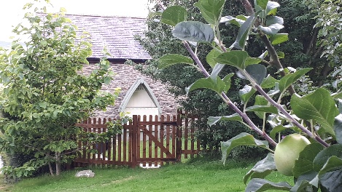
Gwenoldy (Swallows Rest) is an 18th Century stone barn, converted in recent years into holiday accommodation. It sits at right angles to the 17th Century farmhouse which I share with my parents, gorgeous cat Hector, and often one of my adult children. The cottage has central heating, its own private garden, and you are welcome to access the field and orchard which lie behind the garden. Please note that the gardens around the white farmhouse are private. On a rainy day we can set up a table-tennis table in the barn.
Kitchen: Appliances include electric cooker with gas hob, washing machine, microwave, and dishwasher, a kitchen table and 4 chairs. Equipment includes bread maker, coffee filter, pots, pans, cooking dishes, baking trays and sharp knives. Crockery is in good condition - matching place servings for 4 people, glasses, mugs and cutlery. Pantry cupboard – first aid kit, and an emergency supply of drinking water and torch for use only in the event of a power cut (not a usual occurrence!).
We provide: Oil, salt, pepper and hand soap, and our welcome pack contains tea and coffee to start you off. If you are travelling with small children and would appreciate plastic bowls, plates etc, we can provide these.
Living Room: Seating for four, TV stand with TV and DVD, side lights, sound system, bookcase with reading books. The seating has been chosen for comfort and covers are washed regularly. The under stairs cupboard houses: cleaner, drying rack, iron & ironing board, high-chair, and a games box (full of adult and family games). A wider selection of DVDs and games (indoor and outdoor) can be found in the Old Bakehouse. A wood-fired log burner and 1 x basket of logs.
Bathroom: The bath has a shower over and we provide complimentary toiletries: toilet roll, shampoo/shower gel and hand soap. Additional towels available upon request.
Master Bedroom: Newly refurbished for 2021 Double bed with mattress protector, duvet and throw, wardrobe, chest of drawers, dressing table and a beautiful Queen Anne wing back chair. Extra blankets and pillows are provided.
Second Bedroom: Standard layout is 2 x twin beds; wardrobe and chest of drawers. If travelling with younger children, we can provide travel cots FOC. Alternatively, we have 2 x cot beds and can replace one or both twin beds for these (there is a charge for this, and we need plenty of notice).
Garden: A pretty lawned garden with flowers, an arbour, garden table and chairs, sun umbrella and a selection of garden games (housed in the Old Bakehouse); BBQ and a fire-pit. A patio area is planned for late summer 2021 as part of the enhanced landscaping for the garden. The garden is directly accessible from the cottage living room and leads on to the field from behind. Parking for one vehicle is just beyond the garden.
The Old Bakehouse: This is a shared facility where you can find extra games / toys. There is a tumble drier and drying rack in our Laundry Room.
Good to know:
- Our chickens are very friendly but loud noises can prevent them from laying so please keep boisterous play away from them. They live a free-range life within an electrified fence (to keep out predators).
- We have composts for your compostable waste and a suite of recycling bins. Please use these so that we can dispose of your waste in an environmentally friendly way.
- We are not on mains drainage and anything other than toilet paper and human waste can cause thousands of pounds worth of damage so please use the waste bins provided for all other waste.
Cleaning Regime: Immediately prior to your arrival, all rooms are hoovered / mopped and dusted; linens and towels changed; bins emptied, and appliances emptied and cleaned. All hard touch points will then be sprayed with an anti-bacterial spray. A cleaning pack will be left as a courtesy for use during your stay.
North Wales has so much to offer and our online Local Area Guide will introduce you to some great ideas for days out. We will update the house guide-book with anything relevant during the week of your stay.
If we have not mentioned or thought or something which would make your stay more comfortable please ask.

